ANNQUEST FEBRUARY 2018
ISSN: 2321-3043
www.stannsannquest.com
PARALYSIS OF THIRD NERVE FOLLOWING HERPES ZOSTER

Dr.Sneha Kosaraju
snehakosaraju457@gmail.com
Dr.Md Ather
ather1958@yahoo.com
Dr. K. S. Madhura
kalmadishrikanthmadhura@gmail.com

Affiliation: Bhaskar Medical College & Hospital, Moinabad

Introduction
- Herpes zoster refers to the typical vesicular rash caused by reactivation of the latent varicella zoster virus(causing chicken pox in childhood) from dorsal root ganglia. It’s incidence increases with age and triggers for reactivation include trauma, febrile illness and immune deficiency. Herpes zoster usually involves the thoracic dermatomes and involvement of the trigeminal (specifically ophthalmic division) nerve is termed as Herpes Zoster Ophthalmicus(HZO). HZO is seen in 15-25% of cases.

- Ocular manifestations include episcleritis, epithelial keratitis(50%), uveitis(30%), nummular keratitis(25-30%), cranial nerve palsies(13%), interstitial keratitis(5%), glaucoma, cataract. Less common complications include optic neuritis and retinitis(acute retinal and progressive outer retinal necrosis, seen in immunocompromised).

Case Report

- Selecting a Templat A 65 year old male patient was referred from the Department of Dermatology, with complaints of inability to open his right eye since 2 days. He gave history of skin lesions over right side of face of 8 days duration. Following onset of rash, he also developed complaints of diminished vision in the right eye, associated with pain. The patient apparently asymptomatic before the onset of rash, was

not a known hypertensive/diabetic/other systemic illnesses, and was not on any chronic medical therapy.
- Examination revealed vesicular skin lesions over right side of scalp, forehead and the upper nose, respecting the midline. Hutchinson’s sign was negative. His right eye findings included visual acuity of counting fingers at a distance of one metre, complete ptosis with mild infraorbital edema. Testing of extraocular movements of the right eye revealed limitation of adduction and supraduction. Binocular movements showed restriction of levoelevation and levodepression of the right eye.
- Anterior segment findings: Circumcorneal congestion, keratitis, anterior chamber flare, circular sluggishly reactive pupil, and grade three nuclear sclerosis. Fundus findings were unremarkable.
- Examination of the left eye, with a visual acuity of counting fingers at four metres, revealed grade 3 nuclear cataract. Remaining findings were unremarkable.

- Investigations: Complete blood picture, random blood sugar were within normal

Nummular keratitis and circumcornealcongestion

limits. HBsAg testing was negative; HIV 1, HIV 2 and VDRL tests were non reactive. MRI brain revealed normal study, except for diffusely spread lacunar infarcts.

- Treatment: The patient was started on Tab.Acivir 800 mg five times/day, Acivir eye ointment five times/day and Cyclogyl eye drops, and was lost to follow up.

Righteye: Limitation of adduction and supraduction.

Binocular movements: Restriction of levoelevation and levodepression of the right eye

Vesicular lesions over right forehead and nose, respecting the midline; complete ptosis of right eye

discussion

Theories for pathogenesis of cranial nerve involvement in herpes zoster include inflammation of the axons of the particular dermatomes, direct inflammatory spread from trigeminal nerve via the cavernous sinus, occlusive vasculitis due to chronic inflammatory cells, immune reaction, and a demyelinating aetiology.

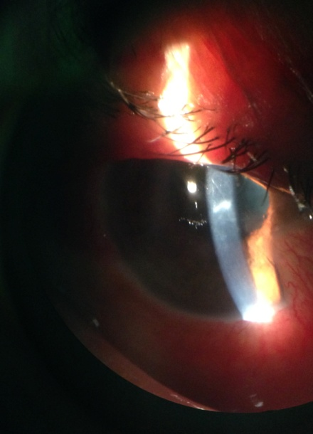
The incidence of extra ocular muscle palsy following HZO was reported to be 13% by Edgerton⁽¹⁾. The most common cranial nerve involvement in HZO is oculomotor(47%), followed by abducens(23%) and trochlear(10%). An additional 20% show complete ophthalmoplegia. Third nerve palsy may be partial or complete, but ptosis is always a manifestation.

In most cases, the onset of ophthalmoplegia is about 9.5 days after the appearance of the typical rash, with a range of 2-42 days⁽²⁾. Unusually, ophthalmoplegia may occur along with the HZO outbreak⁽²⁾. Typically, the ophthalmoplegia is self-limiting and results in complete or near-complete resolution over the course of months.

Since the pupil was not involved in our case, causes of pupil sparing third nerve palsies were excluded(microvascular infarcts, space occupying lesions, aneurysms, infection and trauma).

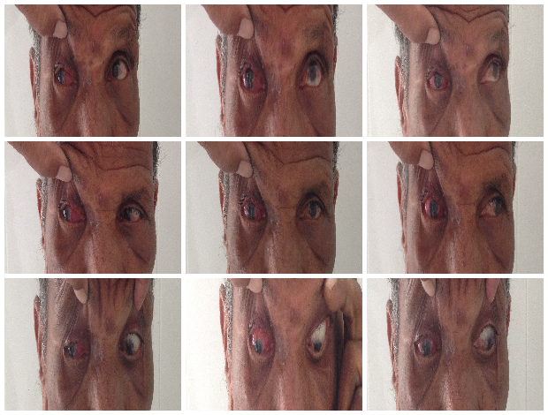
Diagnosis is clinical, with prompt initiation of treatment favouring better prognosis. Antivirals act by resolving skin lesions, decreasing viral shedding and the risk of ocular involvement. The patient was started on Tab.Acivir 800 mg five times/day, Acivir eye ointment five times/day and Cyclogyl eye drops, and was lost to follow up. In ophthalmoplegia, the treatment is unclear due to multiple hypothesised aetiologies. Treatment with oral steroids may decrease both viral load and inflammation, though it must be used with caution in patients with systemic illnesses.

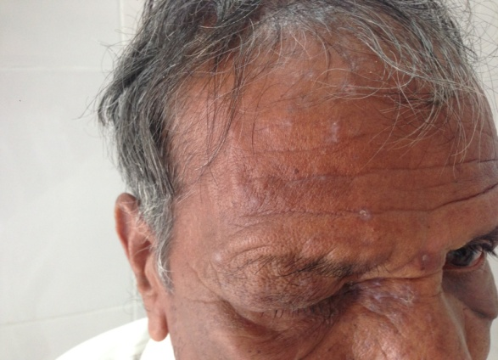
A newer treatment to reduce the risk of zoster is a vaccine, Zostavax (FDA-approved, live attenuated), in adults ≥50 years old⁽³⁾. This may be a useful option in susceptible patients, who have not had herpes zoster outbreaks.

ANNQUEST(7)-4: 20: 22

conclusion
HZO induced ophthalmoplegia is the most common neurological complication in zoster, and usually recovers within 6 months. When a cranial nerve palsy is diagnosed, it is essential to rule out possible life-threatening causes by blood work, imaging, and prompt referral. In this case, our patient presented with partial third nerve palsy which was preceded by typical herpes dermatological manifestations. HZO manifestations often cause visual impairment(keratitis, dry eye, uveitis, optic neuritis) and prompt initiation of treatment is imperative.

References
- Edgerton A.E. Herpes zoster ophthalmicus (Part II) Arch Ophthalmol. 1945;34:114–153
- Complete unilateral ophthalmoplegia in herpes zoster ophthalmicus.Sanjay S, Chan EW, Gopal L, Hegde SR, Chang BC J Neuroophthalmol. 2009 Dec; 29(4):325-37
- Vaccination: a new option to reduce the burden of herpes zoster.Mick G Expert Rev Vaccines. 2010 Mar; 9(3 Suppl):31-5.

