**www.stannsannquest.com**

**ANNQUEST MAY 2022**

**ISSN: 2321-3043**

**EFFECTIVENESS OF INTERMITTENT FASTING ON WEIGHT LOSS**

*Mrs. Hannah Jessie Francis. T, Mrs.Y.V. Phani Kumari, Dr. Meena Kumari Patangay, Ananda Sahithi. T, Himansha. A, Lakshana. K, Sreeja. K, Saisree. B*

**Department of Nutrition, St. Ann’s college for Women, Hyderabad**

**ABSTRACT**

The effects of an intermittent fasting diet in the general population are still controversial. Intermittent fasting, alternate day fasting and other forms of periodic calorie fasting are gaining popularity now a days. The study to systematically evaluate the effectiveness of Intermittent Fasting to reduce body mass index. Comparison of Intermittent fasting diet, Alternate day fasting, Periodic fasting and continuous calorie restriction was done to know the effectiveness of weight loss. The findings from articles suggest that Alternate Day Fasting which includes both complete energy restriction and intermittent energy restriction is more effective for weight loss compared to the Periodic Fasting groups.

**KEY WORDS**

Weight Maintenance Phase, Intermittent Calorie Restriction (ICR), Alternate Day Fasting (ADF), Time restricted Fasting (TRF), Periodic Fasting (PF), Complete Alternate day fasting, modified alternate day fasting.

**INTRODUCTION**

In recent years, weight loss programs, diet plans, and weight maintenance programs have become more popular with people around the world, and there are few studies done on the effectiveness of the programs. Obesity, on the other hand, is increasing in appearance due to many social determinants, such as easy access to various fast foods and lack of physical activity.[1]

Obesity has become a pandemic affecting all populations of all ages living in countries of all income levels [2]. The global increase in the prevalence of overweight and obesity indicates the need for viable weight loss strategies. The intermittent calorie restriction (ICR) diet includes a certain period of caloric restriction and regular caloric intake. Over the past ten years, not only had it remained an alternative to the traditional concept of continuous calorie restriction (CCR), but it also remains popular which must also be attributed to its alleged impact on various health and longevity outcomes [3]. An alternative to calorie restriction is intermittent fasting. This is a broad term that includes some specific fasting protocols. [4] Intermittent fasting is a term that includes a dietary plan that changes between fasting and non-fasting periods [5]. The most studied types of Intermittent Fasting were found to be a 12-hour fast and a 12-hour non-fast. Other types of Intermittent Fasting were also studied, such as fasting every other day, for example, 1 day a week or more fasting and if the fast is longer during the day, for example 16 hours of fasting and 8 hours of non-fasting which is called the time-restricted fasting (TRF) [6] [7].

The list of possible health benefits of intermittent fasting is long: accelerated weight loss, reduced inflammation, reduced cholesterol, increased life expectancy, stabilized blood sugar, and prevention of type 2 diabetes.[8] New research suggests that Intermittent Fasting may help with brain health, longer life expectancy, and even cancer treatment.[24] Dietary time constraints have been shown to have a wide range of systemic effects and trigger biological pathways similar to calorie restriction [9].

As stated above, the dietary practice of using intermittent fasting has an impact on the bodyweight of overweight or obese individuals, as well as in reducing the risk of health problems. Therefore, the objective of this study is to verify the relationship of intermittent fasting on the bodyweight of overweight and obese individuals using anthropometric measurements through a systematic review of literature.

**REVIEW OF LITERATURE**

Ng M, Fleming T, Robinson M (2013) et al, carried out research provide Global, regional, and national prevalence of overweight and obesity in children and adults during 1980–2013: a systematic analysis for the Global Burden of Disease Study 2013. [6]Mejlbo Sundfør, Mette Svendsen, (2018) these studies provide evidence how the intermittent calorie restriction is more effective approach to weight loss by the American journal of clinical nutrition study 2018. [10]Michelle N Harvie, Tony Howell, (2016) et al. gives evidence about could Intermittent Energy Restriction and Intermittent Fasting Reduce Rates of Cancer in Obese, Overweight, A Summary of Evidence, Advances in Nutrition, July 2016, [11]National Heart, Lung, and Blood Institutes of Health, (1998) these studies carried out by, Obesity Education Initiative. Clinical Guidelines on the Identification, Evaluation, and Treatment of Overweight and Obesity in Adults 1998. [12]Benjamin D Horne, Joseph B Muhlestein, Jeffrey L Anderson, (2015) et al, these studies givea systematic reviewon health effects of intermittent fasting: hormesis or harm? Carried out by American Journal of Clinical Nutrition, August 2015. [13]Ruth Schübel, Johanna Nattenmüller, Disorn Sookthai, (2018)et al, these studies give the clear evidence about the effects of intermittent and continuous calorie restriction on body weight and metabolism over 50 randomized controlled trial, The American Journal of Clinical Nutrition, November 2018.[14] Varady KA. Et al, carried outresearch provides the information Intermittent versus daily calorie restriction: these results clearly demonstrate which diet regimen is more effective for weight loss. [15]Rona Antoni1, Kelly L. Johnston, (2016) et al, the study concluded with the findings that there is significant how the intermittent fasting effects on glucose and lipid metabolism Proceedings of the Nutrition Society, July 2016.[16] Hallberg N, Henriksen M, Sondermann N, (2005) et al, these results clearlydemonstrate the Effect of intermittent fasting and refeeding on insulin action in healthy men 2005.[17]Harris, Leanne1; Hamilton, (2018) et al, these research gives the systematic review on Intermittent fasting interventions for treatment of overweight and obesity in adults February 2018. [18]

**DISCUSSION**

The concept of Fasting, Intermittent fasting, Food Timing and Time Restricted feeding were included for the data collection. In addition, relevant research papers from the reference list of research articles were included. According to the study on complete and alternate day fasting it was found that the participants have lost around 1.3kg body weight whereas their body fat ratios did not differ much in number. Also fasting caused a little drop in the blood glucose levels and temporarily raised the uric acid levels.[19][22] Considering the periodic fasting study, the authors have revealed that there was considerable weight loss with both Intermittent Energy Restriction (IER) and Continuous Calorie Restriction (CCR) groups.[4] Based on the duration of intervention carried out the study was found to have weight loss more significant in Alternate day fasting, Complete fasting and also in exercising groups.[15] Another study where the Body mass index was taken into consideration found that there was reduced body fat percent followed in alternate day fasting groups.[20][21]

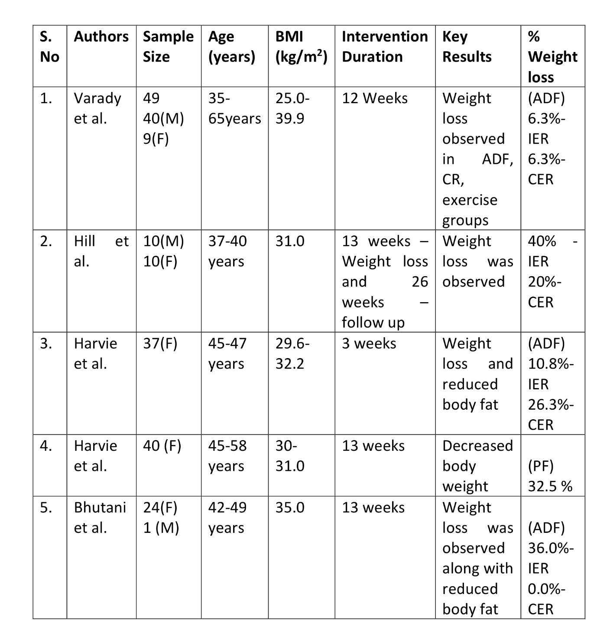

**Table 1** Representing the Authors and their finding based on the BMI and intervention duration in various patterns of Intermittent fasting

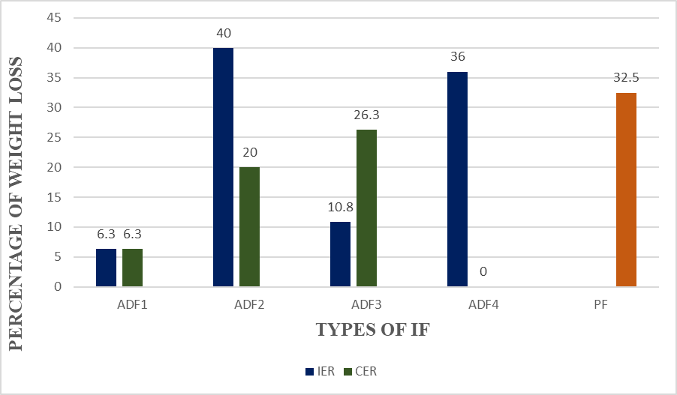

**Graph1** Depicting the percentage of weight loss in different types of Intermittent Fasting

The bar chart illustrates the percentage of weight loss in relation to different forms of intermittent fasting.

In Alternate Day Fasting 1 both Intermittent Energy Restriction and Continuous Energy Restriction have an equal percentage of weight loss i.e., 6.3 %.

In Alternate Day Fasting 2 Intermittent Energy Restriction has a greater percent of weight loss 40% than the Continuous Energy Restriction which is 20%.

In Alternate Day Fasting 3 Continuous Energy Restriction has a larger percentage of weight loss i.e., 26.3 % than Intermittent Energy Restriction which has only 10.8% weight loss

In Alternate Day Fasting 4 Intermittent Energy Restriction has 36% weight loss and there is no weight loss seen in Continuous Energy Restriction

Periodic Fasting has 32.5% weight loss.

From the above bar diagram, it can be concluded that Intermittent Energy Restriction has a higher weight loss percentage than other types of fasting.

**CONCLUSION**

The main objective of this review article is to show a scientifically evident frame to know how intermittent fasting is effective in weight loss using the anthropometric measurements. Alternate day fasting which includes complete energy restriction and intermittent energy restriction and is considered to be the strictest form of intermittent fasting with positive results of weight loss seen when compared to periodic fasting. Further, investigations are needed on the effectiveness, practicability and safety of intermittent calorie restriction for patients with chronic diseases, such as type 2 diabetes mellitus, cardiovascular diseases or cancer.

**ACKNOWLEDGMENTS:**

We would like to express our special thanks of gratitude to our lecturers Mrs. Hannah Jessie Francis. T and Mrs.Y.V. Phani Kumari as well as our department head Dr. Meena Kumari Patangay who gave us the golden opportunity to do this wonderful review article on the topic “Effectiveness of Intermittent Fasting on Weight loss” which has also helped us in doing a lot of research and gained experience for our future projects. We would also like to show our gratitude to all the authors whose articles we have chosen for our review article. We are really thankful to all of them.

**BIBLIOGRAPHY:** -

[1]. Ganesan K, Habboush Y, Sultan S , (2018) Intermittent Fasting: The Choice for a Healthier Lifestyle. *Cureus* 10(7): e2947. DOI 10.7759/cureus.2947.

[2] .Sarah T. Pannen ,Sandra González Maldonado , Tobias Nonnenmacher , Solomon A. Sowah, Laura F. Gruner , Cora Watzinger , Karin Nischwitz , Cornelia M. Ulrich , Rudolf Kaaks , Ruth Schübel , Mirja Grafetstätter and Tilman Kühn (2021) Adherence and Dietary Composition during Intermittent vs Continuous Calorie Restriction, *Journal of Nutrients* Volume 13 Issue 4 10.3390/nu13041195.

[3]. Patterson RE, Sears DD(2017): Metabolic effects of intermittent fasting, *Annual Review of Nutrition*., 37:371-393. 10.1146/annurev-nutr-071816-064634.

[4]. Harvie MN, Pegington M, Mattson MP, Frystyk J, Dillon B, Evans G et al. (2011) The effects of intermittent or continuous energy restriction on weight loss and metabolic disease risk markers: a randomized trial in young overweight women. *International Journal Obesity*.

[5]. Centres for Disease Control and Prevention. Fast State: Obesity and Overweight. http://www.cdc.gov/nchs/fastats/obesity-overweight.htm. Reviewed January 21, 2014. Accessed March 3.

[6]. Ng M, Fleming T, Robinson M et al. (2014) Global, regional, and national prevalence of overweight and obesity in children and adults during 1980–2013: a systematic analysis for the Global Burden of Disease Study 2013. *Lancet* 384, 766–781.

[7]. Julia, C. Peneau, S. Andreeva, V.A. Mejean, C. Fezeu, L. Galan, P. Hercberg, (2014).Weight-loss strategies used by the general population,*PLOS ONE* e97834.

[8] .A.Zubrzycki, K.Cierpka-kmiec, Z.Kmiec, A.Wronska, (2018)The Role of Low-Calorie Diets And Intermittent Fasting in treatment of obesity and type-2 diabetes, *Journal of physiology and pharmacology* 2018,69,5,663-68.

[9] Knower, W.C. Fowler, S.E.Hamman, R.F.Christophi, C.A.Hoffman, H.J.Brenneman, A.T.Brown-Friday, J.O.Goldberg, R.Venditti, E.Nathan, D.M.(2009), 10-year follow-up of diabetes incidence and weight loss in the diabetes prevention program outcomes study.374, 1677–1686.

[10].Tine Mejlbo Sundfør, Mette Svendsen, Serena Tonstad,(2018,November 5) Intermittent calorie restriction—a more effective approach to weight loss, *The American Journal of Clinical Nutrition*, Volume 108, Pages 909–910, <https://doi.org/10.1093/ajcn/nqy288>.

[11] .Michelle N Harvie, Tony Howell,(2016, July 4)Could Intermittent Energy Restriction and Intermittent Fasting Reduce Rates of Cancer in Obese, Overweight, and Normal-Weight Subjects? A Summary of Evidence*, Advances in Nutrition*, Volume 7, Pages 690–705, <https://doi.org/10.3945/an.115.011767>.

[12] . National Heart, Lung, and Blood Institutes of Health, Obesity Education Initiative.(1998). Clinical Guidelines on the Identification, Evaluation, and Treatment of Overweight and Obesity in Adults. Bethesda, MD; *NIH*.

[13] . Benjamin D Horne, Joseph B Muhlestein, Jeffrey L Anderson,(2015,August 2)Health effects of intermittent fasting: hormesis or harm? A systematic review, *The American Journal of Clinical Nutrition*, Volume 102,Pages 464–470, <https://doi.org/10.3945/ajcn.115.109553>.

[14] .Ruth Schübel, Johanna Nattenmüller, Disorn Sookthai, Tobias Nonnenmacher, Mirja E Graf, Lena Riedl, Christopher L Schlett, Oyunbileg von Stackelberg, Theron Johnson, Diana Nabers, Romy Kirsten, Mario Kratz, Hans-Ulrich Kauczor, Cornelia M Ulrich, Rudolf Kaaks, Tilman Kühn, (2018, November 5)Effects of intermittent and continuous calorie restriction on body weight and metabolism over 50 wk: a randomized controlled trial, *The American Journal of Clinical Nutrition*, Volume 108,Pages 933–945, <https://doi.org/10.1093/ajcn/nqy196>.

[15]. Varady KA.(2011) Intermittent versus daily calorie restriction: which diet regimen is more effective for weight loss,12(7): e593-601.

[16]. Rona Antoni1 ,Kelly L. Johnston , Adam L. Collins1 and M. Denise Robertson1(2016) Effects of intermittent fasting on glucose and lipid metabolism *Proceedings of the Nutrition Society*, Page 1 of 8 doi:10.1017/S0029665116002986 Nutrition Society Summer Meeting held at University College.

[17]. Hallberg N, Henriksen M, Sondermann N, Stallknecht B, Plough T, Schjerling P, Dela F,(2005)Effect of intermittent fasting and refeeding on insulin action in healthy men. *Journal of Applied Physiology* .

[18] .Harris, Leanne; Hamilton, Sharon, Azevedo, Liane B, Olajide, Joan, De Brún, Caroline, Waller, Gillian, Whittaker, Vicki, Sharp, Tracey,Lean, Mike1, Hankey, Catherine,Ells, Louisa1,(2018, February 2018)Intermittent fasting interventions for treatment of overweight and obesity in adults, a Volume 16 - p 507-547.

[19]. Soo Liang Ooi , Sok Cheon Pak (2019 )Intermittent fasting for weight loss: A single-subject case design, <https://doi.org/10.1016/j.aimed.2019.03.102>.

[20] .Anton, Stephen D. Keelin Moehl, William ,T. Donahoo, Krisztina Marosi, Stephanie A. Lee, Arch G. Mainous III, Christiaan Leeuwenburgh, and Mark P. Mattson. 2018. “Flipping the Metabolic Switch: Understanding and Appling the Health Benefits of Fasting.” *Obesity* 26 (2): 254–268. <https://doi.org/10.1002/oby>.

[21]. A Johnstone, (2014)Fasting for weight loss: an effective strategy or latest dieting trend? Inter-national *Journal of Obesity* volume 39, pages727–733(2015), Published: 26 December 2014.